**API Testing**

1. Define pokemon “insomnia” ability. Response should include query and effects description: effect and short_effect

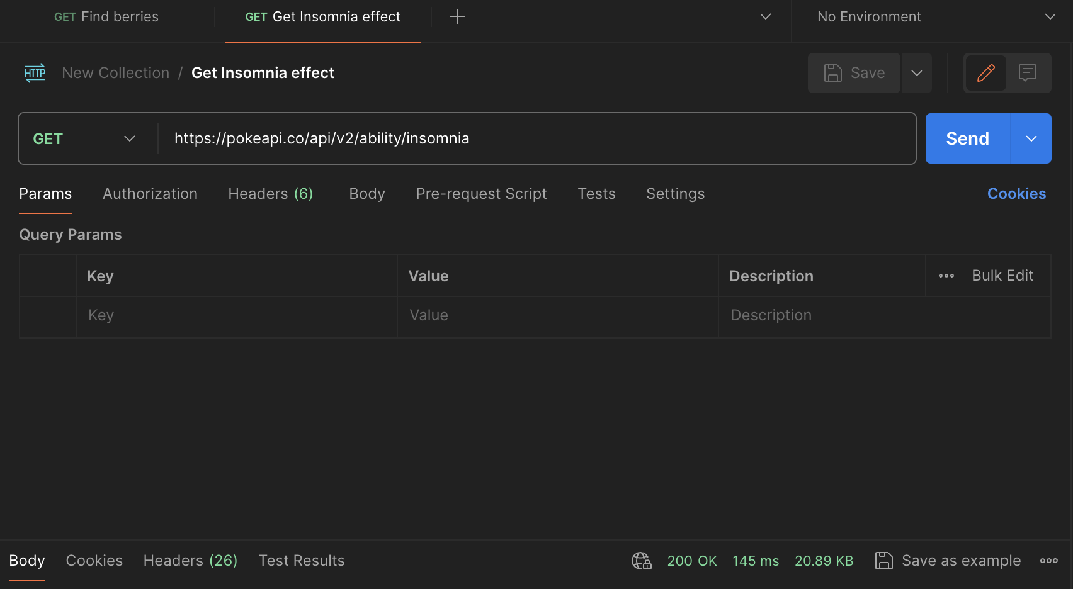

Body:

{

"effect_changes": [],

"effect_entries": [

{

"effect": "Ein Pokémon mit dieser Fähigkeit kann nicht einschlafen.\n\nrest schlägt fehl. Wenn ein Pokémon schläft und diese Fähigkeit erhält, wacht es sofort auf. Das bezieht das Wiedererlangen dieser Fähigkeit nach dem Kampf mit ein.\n\nDiese Fähigkeit ist identisch mit vital spirit.",

"language": {

"name": "de",

"url": "https://pokeapi.co/api/v2/language/6/"

},

"short_effect": "Verhindert sleep."

},

{

"effect": "This Pokémon cannot be asleep.\n\nThis causes rest to fail altogether. If a Pokémon is asleep and acquires this ability, it will immediately wake up; this includes when regaining a lost ability upon leaving battle.\n\nThis ability functions identically to vital spirit in battle.",

"language": {

"name": "en",

"url": "https://pokeapi.co/api/v2/language/9/"

},

"short_effect": "Prevents sleep."

}

],

"flavor_text_entries": [

{

"flavor_text": "Prevents sleep.",

"language": {

"name": "en",

"url": "https://pokeapi.co/api/v2/language/9/"

},

"version_group": {

"name": "ruby-sapphire",

"url": "https://pokeapi.co/api/v2/version-group/5/"

}

},

{

"flavor_text": "Prevents sleep.",

"language": {

"name": "en",

"url": "https://pokeapi.co/api/v2/language/9/"

},

"version_group": {

"name": "emerald",

"url": "https://pokeapi.co/api/v2/version-group/6/"

}

},

{

"flavor_text": "Prevents sleep.",

"language": {

"name": "en",

"url": "https://pokeapi.co/api/v2/language/9/"

},

"version_group": {

"name": "firered-leafgreen",

"url": "https://pokeapi.co/api/v2/version-group/7/"

}

},

{

"flavor_text": "Prevents the Pokémon\nfrom falling asleep.",

"language": {

"name": "en",

"url": "https://pokeapi.co/api/v2/language/9/"

},

"version_group": {

"name": "diamond-pearl",

"url": "https://pokeapi.co/api/v2/version-group/8/"

}

},

{

"flavor_text": "Prevents the Pokémon\nfrom falling asleep.",

"language": {

"name": "en",

"url": "https://pokeapi.co/api/v2/language/9/"

},

"version_group": {

"name": "platinum",

"url": "https://pokeapi.co/api/v2/version-group/9/"

}

},

{

"flavor_text": "Prevents the Pokémon\nfrom falling asleep.",

"language": {

"name": "en",

"url": "https://pokeapi.co/api/v2/language/9/"

},

"version_group": {

"name": "heartgold-soulsilver",

"url": "https://pokeapi.co/api/v2/version-group/10/"

}

},

{

"flavor_text": "Empêche le Pokémon de\ns’endormir.",

"language": {

"name": "fr",

"url": "https://pokeapi.co/api/v2/language/5/"

},

"version_group": {

"name": "black-white",

"url": "https://pokeapi.co/api/v2/version-group/11/"

}

},

{

"flavor_text": "Prevents the Pokémon\nfrom falling asleep.",

"language": {

"name": "en",

"url": "https://pokeapi.co/api/v2/language/9/"

},

"version_group": {

"name": "black-white",

"url": "https://pokeapi.co/api/v2/version-group/11/"

}

},

{

"flavor_text": "Prevents the Pokémon\nfrom falling asleep.",

"language": {

"name": "en",

"url": "https://pokeapi.co/api/v2/language/9/"

},

"version_group": {

"name": "black-2-white-2",

"url": "https://pokeapi.co/api/v2/version-group/14/"

}

},

{

"flavor_text": "ねむり　じょうたいに\nならない。",

"language": {

"name": "ja-Hrkt",

"url": "https://pokeapi.co/api/v2/language/1/"

},

"version_group": {

"name": "x-y",

"url": "https://pokeapi.co/api/v2/version-group/15/"

}

},

{

"flavor_text": "잠듦 상태가\n되지 않는다.",

"language": {

"name": "ko",

"url": "https://pokeapi.co/api/v2/language/3/"

},

"version_group": {

"name": "x-y",

"url": "https://pokeapi.co/api/v2/version-group/15/"

}

},

{

"flavor_text": "Empêche le Pokémon de\ns’endormir.",

"language": {

"name": "fr",

"url": "https://pokeapi.co/api/v2/language/5/"

},

"version_group": {

"name": "x-y",

"url": "https://pokeapi.co/api/v2/version-group/15/"

}

},

{

"flavor_text": "Verhindert Einschlafen.",

"language": {

"name": "de",

"url": "https://pokeapi.co/api/v2/language/6/"

},

"version_group": {

"name": "x-y",

"url": "https://pokeapi.co/api/v2/version-group/15/"

}

},

{

"flavor_text": "Evita el quedarse dormido.",

"language": {

"name": "es",

"url": "https://pokeapi.co/api/v2/language/7/"

},

"version_group": {

"name": "x-y",

"url": "https://pokeapi.co/api/v2/version-group/15/"

}

},

{

"flavor_text": "Impedisce al Pokémon\ndi addormentarsi.",

"language": {

"name": "it",

"url": "https://pokeapi.co/api/v2/language/8/"

},

"version_group": {

"name": "x-y",

"url": "https://pokeapi.co/api/v2/version-group/15/"

}

},

{

"flavor_text": "Prevents the Pokémon\nfrom falling asleep.",

"language": {

"name": "en",

"url": "https://pokeapi.co/api/v2/language/9/"

},

"version_group": {

"name": "x-y",

"url": "https://pokeapi.co/api/v2/version-group/15/"

}

},

{

"flavor_text": "ねむり状態に\nならない。",

"language": {

"name": "ja",

"url": "https://pokeapi.co/api/v2/language/11/"

},

"version_group": {

"name": "x-y",

"url": "https://pokeapi.co/api/v2/version-group/15/"

}

},

{

"flavor_text": "ねむり　じょうたいに\nならない。",

"language": {

"name": "ja-Hrkt",

"url": "https://pokeapi.co/api/v2/language/1/"

},

"version_group": {

"name": "omega-ruby-alpha-sapphire",

"url": "https://pokeapi.co/api/v2/version-group/16/"

}

},

{

"flavor_text": "잠듦 상태가\n되지 않는다.",

"language": {

"name": "ko",

"url": "https://pokeapi.co/api/v2/language/3/"

},

"version_group": {

"name": "omega-ruby-alpha-sapphire",

"url": "https://pokeapi.co/api/v2/version-group/16/"

}

},

{

"flavor_text": "Empêche le Pokémon de\ns’endormir.",

"language": {

"name": "fr",

"url": "https://pokeapi.co/api/v2/language/5/"

},

"version_group": {

"name": "omega-ruby-alpha-sapphire",

"url": "https://pokeapi.co/api/v2/version-group/16/"

}

},

{

"flavor_text": "Verhindert Einschlafen.",

"language": {

"name": "de",

"url": "https://pokeapi.co/api/v2/language/6/"

},

"version_group": {

"name": "omega-ruby-alpha-sapphire",

"url": "https://pokeapi.co/api/v2/version-group/16/"

}

},

{

"flavor_text": "Evita el quedarse dormido.",

"language": {

"name": "es",

"url": "https://pokeapi.co/api/v2/language/7/"

},

"version_group": {

"name": "omega-ruby-alpha-sapphire",

"url": "https://pokeapi.co/api/v2/version-group/16/"

}

},

{

"flavor_text": "Impedisce al Pokémon\ndi addormentarsi.",

"language": {

"name": "it",

"url": "https://pokeapi.co/api/v2/language/8/"

},

"version_group": {

"name": "omega-ruby-alpha-sapphire",

"url": "https://pokeapi.co/api/v2/version-group/16/"

}

},

{

"flavor_text": "Prevents the Pokémon\nfrom falling asleep.",

"language": {

"name": "en",

"url": "https://pokeapi.co/api/v2/language/9/"

},

"version_group": {

"name": "omega-ruby-alpha-sapphire",

"url": "https://pokeapi.co/api/v2/version-group/16/"

}

},

{

"flavor_text": "ねむり状態に\nならない。",

"language": {

"name": "ja",

"url": "https://pokeapi.co/api/v2/language/11/"

},

"version_group": {

"name": "omega-ruby-alpha-sapphire",

"url": "https://pokeapi.co/api/v2/version-group/16/"

}

},

{

"flavor_text": "ねむれない　たいしつ　なので\nねむり　じょうたいに　ならない。",

"language": {

"name": "ja-Hrkt",

"url": "https://pokeapi.co/api/v2/language/1/"

},

"version_group": {

"name": "sun-moon",

"url": "https://pokeapi.co/api/v2/version-group/17/"

}

},

{

"flavor_text": "잠들지 못하는 체질이라\n잠듦 상태가 되지 않는다.",

"language": {

"name": "ko",

"url": "https://pokeapi.co/api/v2/language/3/"

},

"version_group": {

"name": "sun-moon",

"url": "https://pokeapi.co/api/v2/version-group/17/"

}

},

{

"flavor_text": "因為擁有不會睡覺的體質，\n所以不會陷入睡眠狀態。",

"language": {

"name": "zh-Hant",

"url": "https://pokeapi.co/api/v2/language/4/"

},

"version_group": {

"name": "sun-moon",

"url": "https://pokeapi.co/api/v2/version-group/17/"

}

},

{

"flavor_text": "Le Pokémon est incapable de dormir.",

"language": {

"name": "fr",

"url": "https://pokeapi.co/api/v2/language/5/"

},

"version_group": {

"name": "sun-moon",

"url": "https://pokeapi.co/api/v2/version-group/17/"

}

},

{

"flavor_text": "Verhindert Einschlafen.",

"language": {

"name": "de",

"url": "https://pokeapi.co/api/v2/language/6/"

},

"version_group": {

"name": "sun-moon",

"url": "https://pokeapi.co/api/v2/version-group/17/"

}

},

{

"flavor_text": "Su resistencia al sueño le impide quedarse dormido.",

"language": {

"name": "es",

"url": "https://pokeapi.co/api/v2/language/7/"

},

"version_group": {

"name": "sun-moon",

"url": "https://pokeapi.co/api/v2/version-group/17/"

}

},

{

"flavor_text": "Il Pokémon soffre d’insonnia e non può finire\naddormentato.",

"language": {

"name": "it",

"url": "https://pokeapi.co/api/v2/language/8/"

},

"version_group": {

"name": "sun-moon",

"url": "https://pokeapi.co/api/v2/version-group/17/"

}

},

{

"flavor_text": "The Pokémon is suffering from insomnia and cannot\nfall asleep.",

"language": {

"name": "en",

"url": "https://pokeapi.co/api/v2/language/9/"

},

"version_group": {

"name": "sun-moon",

"url": "https://pokeapi.co/api/v2/version-group/17/"

}

},

{

"flavor_text": "眠れない　体質　なので\nねむり状態に　ならない。",

"language": {

"name": "ja",

"url": "https://pokeapi.co/api/v2/language/11/"

},

"version_group": {

"name": "sun-moon",

"url": "https://pokeapi.co/api/v2/version-group/17/"

}

},

{

"flavor_text": "因为是不会睡觉的体质，\n所以不会变为睡眠状态。",

"language": {

"name": "zh-Hans",

"url": "https://pokeapi.co/api/v2/language/12/"

},

"version_group": {

"name": "sun-moon",

"url": "https://pokeapi.co/api/v2/version-group/17/"

}

},

{

"flavor_text": "ねむれない　たいしつ　なので\nねむり　じょうたいに　ならない。",

"language": {

"name": "ja-Hrkt",

"url": "https://pokeapi.co/api/v2/language/1/"

},

"version_group": {

"name": "ultra-sun-ultra-moon",

"url": "https://pokeapi.co/api/v2/version-group/18/"

}

},

{

"flavor_text": "잠들지 못하는 체질이라\n잠듦 상태가 되지 않는다.",

"language": {

"name": "ko",

"url": "https://pokeapi.co/api/v2/language/3/"

},

"version_group": {

"name": "ultra-sun-ultra-moon",

"url": "https://pokeapi.co/api/v2/version-group/18/"

}

},

{

"flavor_text": "因為擁有不會睡覺的體質，\n所以不會陷入睡眠狀態。",

"language": {

"name": "zh-Hant",

"url": "https://pokeapi.co/api/v2/language/4/"

},

"version_group": {

"name": "ultra-sun-ultra-moon",

"url": "https://pokeapi.co/api/v2/version-group/18/"

}

},

{

"flavor_text": "Le Pokémon est incapable de dormir.",

"language": {

"name": "fr",

"url": "https://pokeapi.co/api/v2/language/5/"

},

"version_group": {

"name": "ultra-sun-ultra-moon",

"url": "https://pokeapi.co/api/v2/version-group/18/"

}

},

{

"flavor_text": "Verhindert Einschlafen.",

"language": {

"name": "de",

"url": "https://pokeapi.co/api/v2/language/6/"

},

"version_group": {

"name": "ultra-sun-ultra-moon",

"url": "https://pokeapi.co/api/v2/version-group/18/"

}

},

{

"flavor_text": "Su resistencia al sueño le impide quedarse dormido.",

"language": {

"name": "es",

"url": "https://pokeapi.co/api/v2/language/7/"

},

"version_group": {

"name": "ultra-sun-ultra-moon",

"url": "https://pokeapi.co/api/v2/version-group/18/"

}

},

{

"flavor_text": "Il Pokémon soffre d’insonnia e non può finire\naddormentato.",

"language": {

"name": "it",

"url": "https://pokeapi.co/api/v2/language/8/"

},

"version_group": {

"name": "ultra-sun-ultra-moon",

"url": "https://pokeapi.co/api/v2/version-group/18/"

}

},

{

"flavor_text": "The Pokémon is suffering from insomnia and cannot\nfall asleep.",

"language": {

"name": "en",

"url": "https://pokeapi.co/api/v2/language/9/"

},

"version_group": {

"name": "ultra-sun-ultra-moon",

"url": "https://pokeapi.co/api/v2/version-group/18/"

}

},

{

"flavor_text": "眠れない　体質　なので\nねむり状態に　ならない。",

"language": {

"name": "ja",

"url": "https://pokeapi.co/api/v2/language/11/"

},

"version_group": {

"name": "ultra-sun-ultra-moon",

"url": "https://pokeapi.co/api/v2/version-group/18/"

}

},

{

"flavor_text": "因为是不会睡觉的体质，\n所以不会变为睡眠状态。",

"language": {

"name": "zh-Hans",

"url": "https://pokeapi.co/api/v2/language/12/"

},

"version_group": {

"name": "ultra-sun-ultra-moon",

"url": "https://pokeapi.co/api/v2/version-group/18/"

}

},

{

"flavor_text": "ねむれない　たいしつ　なので\nねむり　じょうたいに　ならない。",

"language": {

"name": "ja-Hrkt",

"url": "https://pokeapi.co/api/v2/language/1/"

},

"version_group": {

"name": "lets-go-pikachu-lets-go-eevee",

"url": "https://pokeapi.co/api/v2/version-group/19/"

}

},

{

"flavor_text": "잠들지 못하는 체질이라\n잠듦 상태가 되지 않는다.",

"language": {

"name": "ko",

"url": "https://pokeapi.co/api/v2/language/3/"

},

"version_group": {

"name": "lets-go-pikachu-lets-go-eevee",

"url": "https://pokeapi.co/api/v2/version-group/19/"

}

},

{

"flavor_text": "因為擁有不會睡覺的體質，\n所以不會陷入睡眠狀態。",

"language": {

"name": "zh-Hant",

"url": "https://pokeapi.co/api/v2/language/4/"

},

"version_group": {

"name": "lets-go-pikachu-lets-go-eevee",

"url": "https://pokeapi.co/api/v2/version-group/19/"

}

},

{

"flavor_text": "Le Pokémon est incapable de dormir.",

"language": {

"name": "fr",

"url": "https://pokeapi.co/api/v2/language/5/"

},

"version_group": {

"name": "lets-go-pikachu-lets-go-eevee",

"url": "https://pokeapi.co/api/v2/version-group/19/"

}

},

{

"flavor_text": "Verhindert Einschlafen.",

"language": {

"name": "de",

"url": "https://pokeapi.co/api/v2/language/6/"

},

"version_group": {

"name": "lets-go-pikachu-lets-go-eevee",

"url": "https://pokeapi.co/api/v2/version-group/19/"

}

},

{

"flavor_text": "Su resistencia al sueño le impide quedarse dormido.",

"language": {

"name": "es",

"url": "https://pokeapi.co/api/v2/language/7/"

},

"version_group": {

"name": "lets-go-pikachu-lets-go-eevee",

"url": "https://pokeapi.co/api/v2/version-group/19/"

}

},

{

"flavor_text": "Il Pokémon soffre d’insonnia e non può finire\naddormentato.",

"language": {

"name": "it",

"url": "https://pokeapi.co/api/v2/language/8/"

},

"version_group": {

"name": "lets-go-pikachu-lets-go-eevee",

"url": "https://pokeapi.co/api/v2/version-group/19/"

}

},

{

"flavor_text": "The Pokémon is suffering from insomnia and cannot\nfall asleep.",

"language": {

"name": "en",

"url": "https://pokeapi.co/api/v2/language/9/"

},

"version_group": {

"name": "lets-go-pikachu-lets-go-eevee",

"url": "https://pokeapi.co/api/v2/version-group/19/"

}

},

{

"flavor_text": "眠れない　体質　なので\nねむり状態に　ならない。",

"language": {

"name": "ja",

"url": "https://pokeapi.co/api/v2/language/11/"

},

"version_group": {

"name": "lets-go-pikachu-lets-go-eevee",

"url": "https://pokeapi.co/api/v2/version-group/19/"

}

},

{

"flavor_text": "因为是不会睡觉的体质，\n所以不会变为睡眠状态。",

"language": {

"name": "zh-Hans",

"url": "https://pokeapi.co/api/v2/language/12/"

},

"version_group": {

"name": "lets-go-pikachu-lets-go-eevee",

"url": "https://pokeapi.co/api/v2/version-group/19/"

}

},

{

"flavor_text": "ねむれない　たいしつ　なので\nねむり　じょうたいに　ならない。",

"language": {

"name": "ja-Hrkt",

"url": "https://pokeapi.co/api/v2/language/1/"

},

"version_group": {

"name": "sword-shield",

"url": "https://pokeapi.co/api/v2/version-group/20/"

}

},

{

"flavor_text": "잠들지 못하는 체질이라\n잠듦 상태가 되지 않는다.",

"language": {

"name": "ko",

"url": "https://pokeapi.co/api/v2/language/3/"

},

"version_group": {

"name": "sword-shield",

"url": "https://pokeapi.co/api/v2/version-group/20/"

}

},

{

"flavor_text": "因為有著睡不著的體質，\n所以不會陷入睡眠狀態。",

"language": {

"name": "zh-Hant",

"url": "https://pokeapi.co/api/v2/language/4/"

},

"version_group": {

"name": "sword-shield",

"url": "https://pokeapi.co/api/v2/version-group/20/"

}

},

{

"flavor_text": "Le Pokémon est incapable de dormir.",

"language": {

"name": "fr",

"url": "https://pokeapi.co/api/v2/language/5/"

},

"version_group": {

"name": "sword-shield",

"url": "https://pokeapi.co/api/v2/version-group/20/"

}

},

{

"flavor_text": "Verhindert Einschlafen.",

"language": {

"name": "de",

"url": "https://pokeapi.co/api/v2/language/6/"

},

"version_group": {

"name": "sword-shield",

"url": "https://pokeapi.co/api/v2/version-group/20/"

}

},

{

"flavor_text": "Su resistencia al sueño le impide quedarse dormido.",

"language": {

"name": "es",

"url": "https://pokeapi.co/api/v2/language/7/"

},

"version_group": {

"name": "sword-shield",

"url": "https://pokeapi.co/api/v2/version-group/20/"

}

},

{

"flavor_text": "Il Pokémon soffre d’insonnia e non può addormentarsi.",

"language": {

"name": "it",

"url": "https://pokeapi.co/api/v2/language/8/"

},

"version_group": {

"name": "sword-shield",

"url": "https://pokeapi.co/api/v2/version-group/20/"

}

},

{

"flavor_text": "The Pokémon is suffering from insomnia and cannot\nfall asleep.",

"language": {

"name": "en",

"url": "https://pokeapi.co/api/v2/language/9/"

},

"version_group": {

"name": "sword-shield",

"url": "https://pokeapi.co/api/v2/version-group/20/"

}

},

{

"flavor_text": "眠れない　体質　なので\nねむり状態に　ならない。",

"language": {

"name": "ja",

"url": "https://pokeapi.co/api/v2/language/11/"

},

"version_group": {

"name": "sword-shield",

"url": "https://pokeapi.co/api/v2/version-group/20/"

}

},

{

"flavor_text": "因为有着睡不着的体质，\n所以不会陷入睡眠状态。",

"language": {

"name": "zh-Hans",

"url": "https://pokeapi.co/api/v2/language/12/"

},

"version_group": {

"name": "sword-shield",

"url": "https://pokeapi.co/api/v2/version-group/20/"

}

},

{

"flavor_text": "The Pokémon's insomnia prevents it from falling asleep.",

"language": {

"name": "en",

"url": "https://pokeapi.co/api/v2/language/9/"

},

"version_group": {

"name": "sword-shield",

"url": "https://pokeapi.co/api/v2/version-group/20/"

}

}

],

"generation": {

"name": "generation-iii",

"url": "https://pokeapi.co/api/v2/generation/3/"

},

"id": 15,

"is_main_series": true,

"name": "insomnia",

"names": [

{

"language": {

"name": "ja-Hrkt",

"url": "https://pokeapi.co/api/v2/language/1/"

},

"name": "ふみん"

},

{

"language": {

"name": "ko",

"url": "https://pokeapi.co/api/v2/language/3/"

},

"name": "불면"

},

{

"language": {

"name": "zh-Hant",

"url": "https://pokeapi.co/api/v2/language/4/"

},

"name": "不眠"

},

{

"language": {

"name": "fr",

"url": "https://pokeapi.co/api/v2/language/5/"

},

"name": "Insomnia"

},

{

"language": {

"name": "de",

"url": "https://pokeapi.co/api/v2/language/6/"

},

"name": "Insomnia"

},

{

"language": {

"name": "es",

"url": "https://pokeapi.co/api/v2/language/7/"

},

"name": "Insomnio"

},

{

"language": {

"name": "it",

"url": "https://pokeapi.co/api/v2/language/8/"

},

"name": "Insonnia"

},

{

"language": {

"name": "en",

"url": "https://pokeapi.co/api/v2/language/9/"

},

"name": "Insomnia"

},

{

"language": {

"name": "ja",

"url": "https://pokeapi.co/api/v2/language/11/"

},

"name": "ふみん"

},

{

"language": {

"name": "zh-Hans",

"url": "https://pokeapi.co/api/v2/language/12/"

},

"name": "不眠"

}

],

"pokemon": [

{

"is_hidden": false,

"pokemon": {

"name": "drowzee",

"url": "https://pokeapi.co/api/v2/pokemon/96/"

},

"slot": 1

},

{

"is_hidden": false,

"pokemon": {

"name": "hypno",

"url": "https://pokeapi.co/api/v2/pokemon/97/"

},

"slot": 1

},

{

"is_hidden": false,

"pokemon": {

"name": "hoothoot",

"url": "https://pokeapi.co/api/v2/pokemon/163/"

},

"slot": 1

},

{

"is_hidden": false,

"pokemon": {

"name": "noctowl",

"url": "https://pokeapi.co/api/v2/pokemon/164/"

},

"slot": 1

},

{

"is_hidden": false,

"pokemon": {

"name": "spinarak",

"url": "https://pokeapi.co/api/v2/pokemon/167/"

},

"slot": 2

},

{

"is_hidden": false,

"pokemon": {

"name": "ariados",

"url": "https://pokeapi.co/api/v2/pokemon/168/"

},

"slot": 2

},

{

"is_hidden": false,

"pokemon": {

"name": "murkrow",

"url": "https://pokeapi.co/api/v2/pokemon/198/"

},

"slot": 1

},

{

"is_hidden": true,

"pokemon": {

"name": "delibird",

"url": "https://pokeapi.co/api/v2/pokemon/225/"

},

"slot": 3

},

{

"is_hidden": false,

"pokemon": {

"name": "shuppet",

"url": "https://pokeapi.co/api/v2/pokemon/353/"

},

"slot": 1

},

{

"is_hidden": false,

"pokemon": {

"name": "banette",

"url": "https://pokeapi.co/api/v2/pokemon/354/"

},

"slot": 1

},

{

"is_hidden": false,

"pokemon": {

"name": "honchkrow",

"url": "https://pokeapi.co/api/v2/pokemon/430/"

},

"slot": 1

},

{

"is_hidden": true,

"pokemon": {

"name": "pumpkaboo-average",

"url": "https://pokeapi.co/api/v2/pokemon/710/"

},

"slot": 3

},

{

"is_hidden": true,

"pokemon": {

"name": "gourgeist-average",

"url": "https://pokeapi.co/api/v2/pokemon/711/"

},

"slot": 3

},

{

"is_hidden": false,

"pokemon": {

"name": "tarountula",

"url": "https://pokeapi.co/api/v2/pokemon/917/"

},

"slot": 1

},

{

"is_hidden": false,

"pokemon": {

"name": "spidops",

"url": "https://pokeapi.co/api/v2/pokemon/918/"

},

"slot": 1

},

{

"is_hidden": false,

"pokemon": {

"name": "capsakid",

"url": "https://pokeapi.co/api/v2/pokemon/951/"

},

"slot": 2

},

{

"is_hidden": false,

"pokemon": {

"name": "scovillain",

"url": "https://pokeapi.co/api/v2/pokemon/952/"

},

"slot": 2

},

{

"is_hidden": true,

"pokemon": {

"name": "pumpkaboo-small",

"url": "https://pokeapi.co/api/v2/pokemon/10027/"

},

"slot": 3

},

{

"is_hidden": true,

"pokemon": {

"name": "pumpkaboo-large",

"url": "https://pokeapi.co/api/v2/pokemon/10028/"

},

"slot": 3

},

{

"is_hidden": true,

"pokemon": {

"name": "pumpkaboo-super",

"url": "https://pokeapi.co/api/v2/pokemon/10029/"

},

"slot": 3

},

{

"is_hidden": true,

"pokemon": {

"name": "gourgeist-small",

"url": "https://pokeapi.co/api/v2/pokemon/10030/"

},

"slot": 3

},

{

"is_hidden": true,

"pokemon": {

"name": "gourgeist-large",

"url": "https://pokeapi.co/api/v2/pokemon/10031/"

},

"slot": 3

},

{

"is_hidden": true,

"pokemon": {

"name": "gourgeist-super",

"url": "https://pokeapi.co/api/v2/pokemon/10032/"

},

"slot": 3

},

{

"is_hidden": false,

"pokemon": {

"name": "mewtwo-mega-y",

"url": "https://pokeapi.co/api/v2/pokemon/10044/"

},

"slot": 1

}

]

}

2) Find all berries with firmness “hard”. Response should include a query.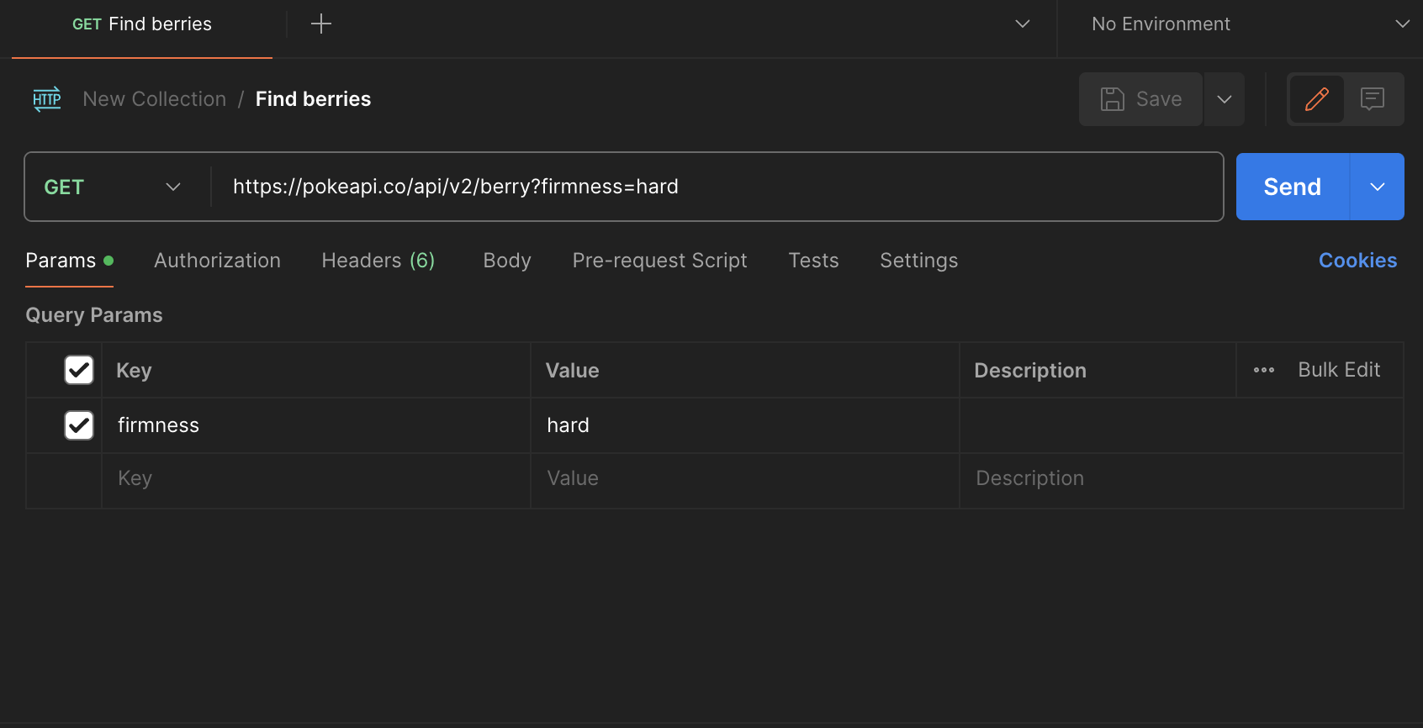

Body:

{

"count": 64,

"next": "https://pokeapi.co/api/v2/berry?offset=20&limit=20",

"previous": null,

"results": [

{

"name": "cheri",

"url": "https://pokeapi.co/api/v2/berry/1/"

},

{

"name": "chesto",

"url": "https://pokeapi.co/api/v2/berry/2/"

},

{

"name": "pecha",

"url": "https://pokeapi.co/api/v2/berry/3/"

},

{

"name": "rawst",

"url": "https://pokeapi.co/api/v2/berry/4/"

},

{

"name": "aspear",

"url": "https://pokeapi.co/api/v2/berry/5/"

},

{

"name": "leppa",

"url": "https://pokeapi.co/api/v2/berry/6/"

},

{

"name": "oran",

"url": "https://pokeapi.co/api/v2/berry/7/"

},

{

"name": "persim",

"url": "https://pokeapi.co/api/v2/berry/8/"

},

{

"name": "lum",

"url": "https://pokeapi.co/api/v2/berry/9/"

},

{

"name": "sitrus",

"url": "https://pokeapi.co/api/v2/berry/10/"

},

{

"name": "figy",

"url": "https://pokeapi.co/api/v2/berry/11/"

},

{

"name": "wiki",

"url": "https://pokeapi.co/api/v2/berry/12/"

},

{

"name": "mago",

"url": "https://pokeapi.co/api/v2/berry/13/"

},

{

"name": "aguav",

"url": "https://pokeapi.co/api/v2/berry/14/"

},

{

"name": "iapapa",

"url": "https://pokeapi.co/api/v2/berry/15/"

},

{

"name": "razz",

"url": "https://pokeapi.co/api/v2/berry/16/"

},

{

"name": "bluk",

"url": "https://pokeapi.co/api/v2/berry/17/"

},

{

"name": "nanab",

"url": "https://pokeapi.co/api/v2/berry/18/"

},

{

"name": "wepear",

"url": "https://pokeapi.co/api/v2/berry/19/"

},

{

"name": "pinap",

"url": "https://pokeapi.co/api/v2/berry/20/"

}

]

}